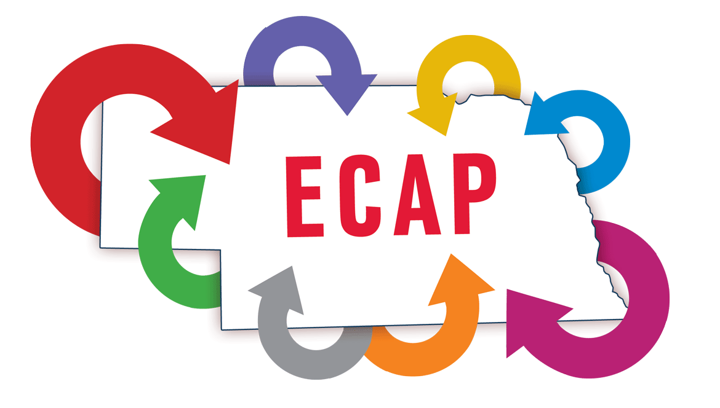

CREIGHTON

DISCOVERY TOOL RESULTS

October 21, 2019

Table of Contents

About the Discovery Tool 2
Creighton Discovery Tool Process 2
Community Vision, Sense of Place, Culture of Change, and Leadership 3
Infrastructure, Digitally Connected, Education/ Workforce IQ and Entrepreneurial Support
Systems 7
Creighton Services, Amenities, Projects and Economic Development 11
Retail Shopping 15
Housing 18
Business Ownership 19
Community Involvement 20
Demographics 21
About the Entrepreneurial Community Activation Process (ECAP) 24

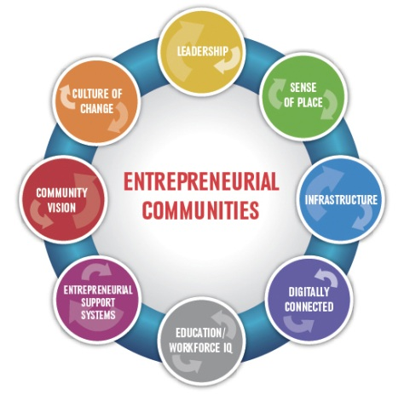

About the Discovery Tool
The Discovery Tool is an online tool developed to measure how residents view their community relative to the eight characteristics. Residents are asked to rate various dimensions of their community. For these items respondents rated each on a scale from 1 to 5, where 1 denoted “not at all” and 5 indicated “completely.” Residents are also asked a couple open-ended questions about their community as well as some standard demographic questions that are used to make comparisons among community residents.
In addition, at the request of the Creighton steering committee, residents were asked a number of other questions. Those question topics included: community services and amenities, economic development, retail shopping, housing, and business ownership.

Creighton Discovery Tool Process
In Creighton, the online ECAP Discovery Tool was marketed to community residents through various sources. The residents also had the option of completing a paper copy of the survey. A total of 190 residents completed at least part of the Discovery Tool.

Community Vision, Sense of Place, Culture of Change, and Leadership
The community was rated by residents on 36 different dimensions, each using a five-point scale where 1 indicated “not at all” and 5 denoted “completely.” The responses to 18 of the dimensions are shown in the following charts.
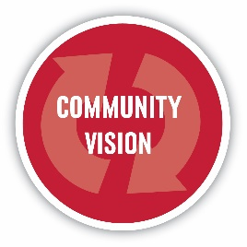
Almost four in ten respondents believe Creighton has a strong identity and almost three in ten say it has a sense of purpose and just under three in ten say Creighton has a sense of purpose. Just under one-quarter believe it shares information openly. However, less than two in ten of the respondents believe the community creates opportunities for diverse community member involvement in visioning and planning processes, has a shared vision for the future, has goals to accomplish the vision, and that the community listens to people’s opinions.

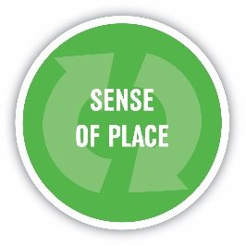
Almost one-third of respondents say Creighton has a majority of residents who have strong pride in the community. Almost three in ten respondents believe Creighton celebrates its heritage and culture, has a majority of residents who feel they belong in the community and has a majority of residents who strongly identify with the community.

Less than two in ten respondents believe Creighton is open to new ideas, that it promotes innovation and creativity and that the community proactively drives change.

Almost three in ten respondents believe Creighton uses a variety of tools for communication to keep citizens in the loop and just under one-quarter say it has leaders who are motivated to improve the economic and social well-being in the community. Two in ten respondents believe the community has leaders who work together to solve issues. And, just under two in ten believe it has leaders who engage and empower citizens.

Infrastructure, Digitally Connected, Education/ Workforce IQ and Entrepreneurial Support Systems
The responses to the remaining 18 community rating scales are shown in the following charts.
Just over two-thirds of the respondents (67%) believe Creighton has health care facilities that provide adequate levels of care. However, fewer than two in ten respondents believe Creighton maintains existing infrastructure capable of servicing current needs, that it has the transportation infrastructure necessary for travel and commerce, that the community anticipates and plans for long-range infrastructure needs and has desirable housing for a range of people and income levels.

Just over two in ten respondents believe Creighton has access to high speed Internet services. Two in ten believe it has leaders who use technology for governing and managing the community and less than two in ten believe the community has affordable high speed Internet services.

Almost one-quarter of respondents believe Creighton prepares students for work and careers in a changing world. Less than two in ten believe the community provides educational opportunities for workers to improve personal and job-related skills. Less than one in ten respondents believe the community provides entrepreneurship and business education for youth and adults and that it provides opportunities for technology/technical education or training.

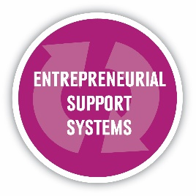
Just over one in ten respondents believe Creighton has legal services for entrepreneurs and has favorable public policies supportive of entrepreneurship and business development. One in ten believe the community has access to capital for entrepreneurs. Less than one in ten believe the community does the following items: has mentoring and networking opportunities for entrepreneurs, has accounting services for entrepreneurs, and has marketing services for entrepreneurs. Many respondents answered don’t know to each of these items.

Creighton Services, Amenities, Projects, and Economic Development
The questions included in this section were requested by the Creighton steering committee. Respondents were asked to rate community amenities in Creighton. Over one-half of the respondents rated the public library, baseball field, Bruce Park, and playground equipment as either good or excellent. In fact, just under six in ten rate the baseball field and public library as excellent.

Creighton is currently exploring building a new community center. Respondents were given a list of items and were asked which they would like to see included in that building if it were to be built. At least one-third of respondents said they would definitely like to see the following included in the community center: large meeting/conference room (54%), an indoor walking/running track (47%), room for birthday parties (38%), activity center (37%) and commercial kitchen (36%).

They were then asked what priority building a new community center should be. Over eight in ten persons (85%) said building a new community center should be either a moderate or high priority.

They were then asked what priority building a new fire hall should be. Over eight in ten persons (86%) said building a new fire hall should be either a moderate or high priority.

Next, respondents were asked about services that can help an aging population. They were asked what priority level each of those services should be. At least one-half of the respondents said the following services should be a high or the highest priority: home health services (62%), assisted living facility (60%), and food services such as Meals on Wheels (58%).

When asked what priority level various items should be regarding Creighton’s future economic growth, at least four in ten residents say the following should be the highest priority: attracting new industry (54%), high-speed Internet services for commerce (50%), attracting new retail businesses (48%), attracting new service businesses (47%), supporting and expanding existing businesses and industry (47%), and supporting existing agricultural businesses (47%).

Retail Shopping
Respondents were given a list of product categories and asked where they are most likely to purchase each. Most respondents are likely to purchase lawn and garden products (69%) and groceries (69%) in Creighton. Almost one-half (44%) are most likely to purchase pet supplies in town. Many specialized products (appliances, electronics, clothing, health and beauty, personal accessories and home furnishings) are most likely purchased either in Norfolk or online.

When asked what factors they consider when shopping, at least seven in ten answered: price (88%), quality (74%), and variety of selection (73%). Just over one-half also consider supporting local businesses (57%), convenience (56%) and customer service (51%).

Most survey respondents shop in the evenings. Seven in ten respondents (70%) typically do their shopping after 5 p.m. Just over one-third (35%) typically shop between 1 and 5 p.m.

Most survey respondents shop on the weekends. Over eight in ten respondents (83%) most frequently shop on Saturday. Just under one-half (48%) said they shop most frequently on Sunday.

Most respondents (62%) said they are very or somewhat likely to do more shopping locally if the hours of the businesses were expanded to include evenings and weekends.

Finally, the respondents were asked about a potential marketplace website that would create a one-stop shop for local businesses that would allow community residents to buy local online. Over six in ten respondents (62%) said creating such an online marketplace should be the highest or a moderate priority.

Housing
Just under one-quarter of respondents live outside Creighton city limits. Those respondents were asked if their desired housing was available, would they move to/within Creighton. Most respondents living outside city limits (80%) said they would not move to Creighton. And, most (92%) prefer private ownership. Five percent would prefer a rental and three percent indicated they would choose a condominium or townhouse.
The respondents living within city limits were asked about their residence. Most respondents living in the community rate their residence as either excellent (34%) or good (54%). Most respondents living in the community (92%) own their home/residence.

All respondents were given various types of housing stock and were asked to rate the adequacy of each. Most respondents rate the following housing types as inadequate: existing affordable homes for sale (55%), higher-end homes for sale (65%), affordable rental units or homes (65%), and new construction affordable homes for sale (70%). Almost one-half (46%) rate housing for the elderly as adequate or better. And, over four in ten (42%) rate subsidized rental housing as adequate or better.

Business Ownership
Respondents were asked if they have ever envisioned starting their own business in or around Creighton. Just over three in ten (31%) have and 16 percent currently own a business in the area.

Those who are currently thinking about starting a business or who currently own one were asked what types of assistance would help them strengthen their business or begin a business venture. At least one-third say the following would help: financial assistance (60%), identification of available resources (47%), and marketing assistance (39%).

Community Involvement
Respondents were asked the extent to which they agree or disagree with various statements about Creighton. At least one-half agree with the following: I can get my basic needs in the community (81%), I have a good bond with others in this community (70%), I feel like a member of this community (68%), I belong in this community (67%), and I feel connected to this community (59%). However, only one-quarter (25%) agree that they have a say about what goes on in this community.

Almost three-quarters (72%) of the respondents have volunteered their time for a community group or organization during the past five years. Almost seven in ten (69%) have belonged to a community group or organization and just over two-thirds (67%) have volunteered their time for a community service project. Four in ten (40%) have held a leadership role in a community group or organization during the past five years and 17 percent have held a public office or served on a government board or committee.

Demographics
The average age of respondents was 45. Just under one-third (32%) of the respondents are age 35 or younger. Just over four in ten (41%) are between the ages of 36 and 55.

Most of the respondents (90%) most closely identify with Creighton. Ten percent most closely identified with a different community, with Verdigre, Bloomfield and Norfolk being the most frequently mentioned. Two in ten respondents (20%) have lived in the community for ten years or less, while 36 percent have lived there for more than 30 years.
Most of the respondents (76%) live within city limits. Just over one in ten live outside city limits on a farm or ranch (13%), five percent live on a nearby acreage and seven percent live in or near another community.
Almost six in ten (59%) work in Creighton and over two in ten (21%) commute to another community for their work.

Respondents were asked their approximate household income for 2018. One-quarter (25%) report household incomes under $40,000. Just over one-half (55%) report incomes between $40,000 and $99,999. Two in ten (20%) have household incomes of $100,000 or more.

When asked how likely it is that they will be living in or near Creighton five years from now, just over three-quarters (76%) say they probably or definitely will.

Seven percent of the respondents would like to become more involved in the community. Another 17 percent answered maybe, they need more information. This represents over 30 people.

About the Entrepreneurial Communities Activation Process (ECAP)
The Entrepreneurial Communities Activation Process (ECAP) is a holistic facilitative process with the goals of attracting and retaining working age population and creating entrepreneurial environments that lead to community vitality. ECAP helps communities support innovation and entrepreneurship by understanding their unique characteristics, community assets and potential opportunities. An extensive review of literature has identified a model of eight characteristics that consistently characterizes entrepreneurial communities, and that contributes to their positive entrepreneurial cultures: Community Vision; Culture of Change; Leadership; Sense of Place; Infrastructure; Digitally Connected; Education/Workforce IQ; and Entrepreneurial Support Systems.

This Community Survey Report is a product of
Nebraska Extension – Community Vitality Initiative
Survey Manager, Rebecca Vogt

University of Nebraska–Lincoln Extension educational programs
abide with the nondiscrimination policies of the University of
Nebraska–Lincoln and the United States Department of Agriculture.

